**R Notebooks: Helpful hints**

* The first part of the document is called the YAML (Yet Another Markup Language). This contains metadata about the file. You can give the document a title and author. As you export your file to different formats, those will display in the output section.  
  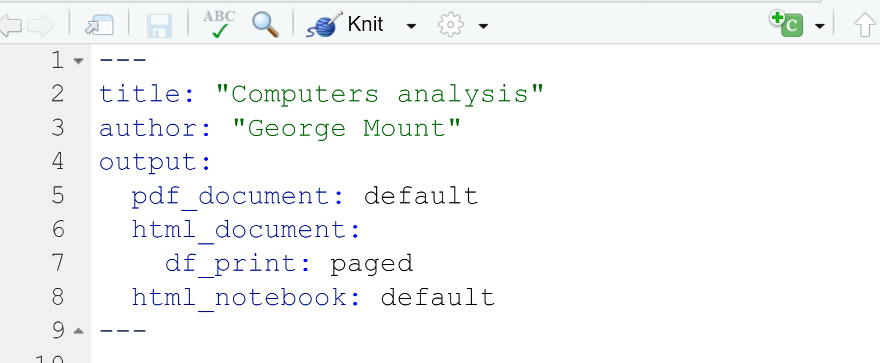
* As you insert headers into the document, you will see button to the left to expand/contract the file:  
  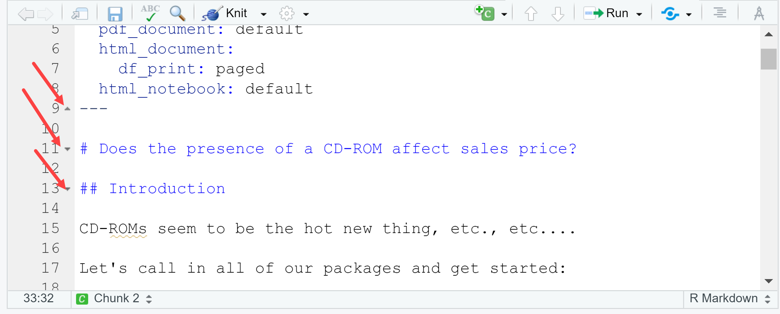
* The C and Run icons will let you, among other things, insert and run chunks, respectively:  
  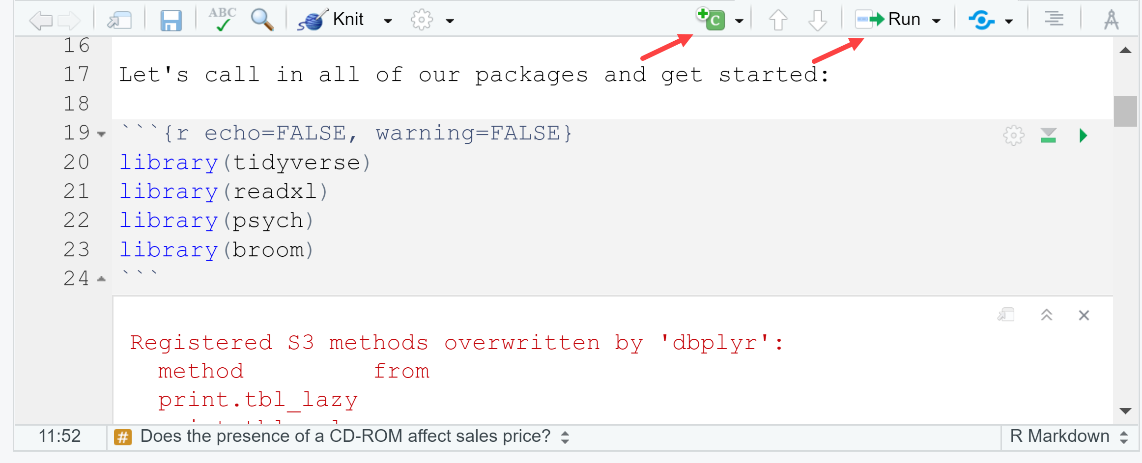
* You can customize the settings of chunks; we’ll use the following (as in previous screenshot). See more at the [official cheat sheet](https://rmarkdown.rstudio.com/lesson-15.html):
  + echo = FALSE will stop code from being shown in the output document
  + warning = FALSE will stop warnings from being shown in document
  + include = FALSE will run the chunk, but no code or output will be shown in the document.
* To view a preview of the document side-by-side with the R Notebook, click on the gearwheel of your document and select “Preview in Viewer Pane.” Then click “Preview” above your doc. The preview will show up in the Viewer pane.
  + This preview does not update on its own; to see subsequent changes to the doc, click Preview again or save the doc.   
    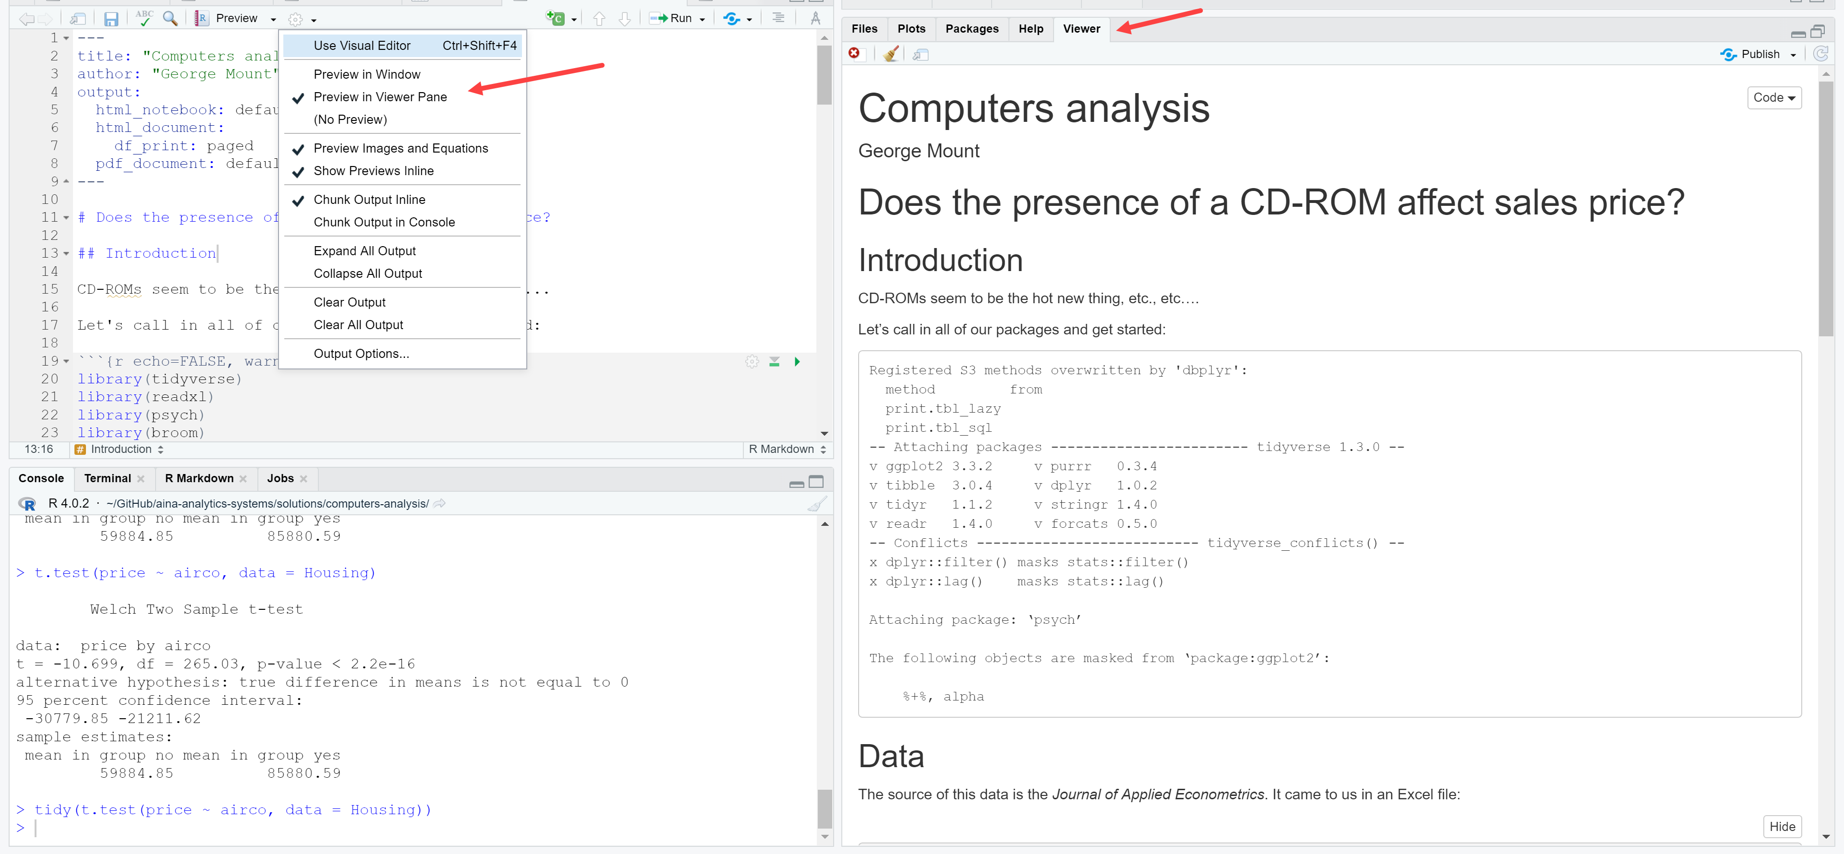
* When you are ready to export the document, click under Preview > Knit to PDF (for example). You will see a log of the export process in the R Markdown tab. The document by default will be exported to wherever your R Notebook is.   
  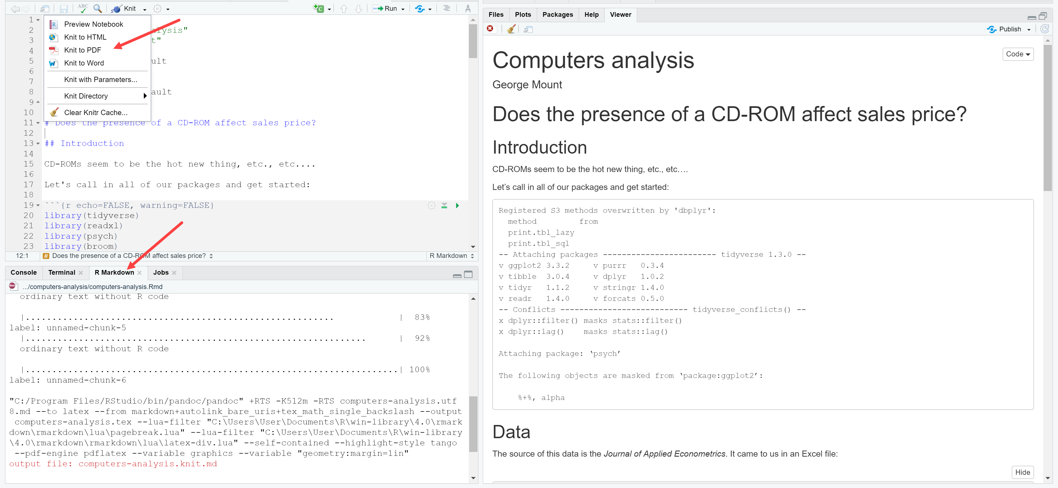
* The tidy() function can be used to present the result of many statistical tests in a more tabular format:  
  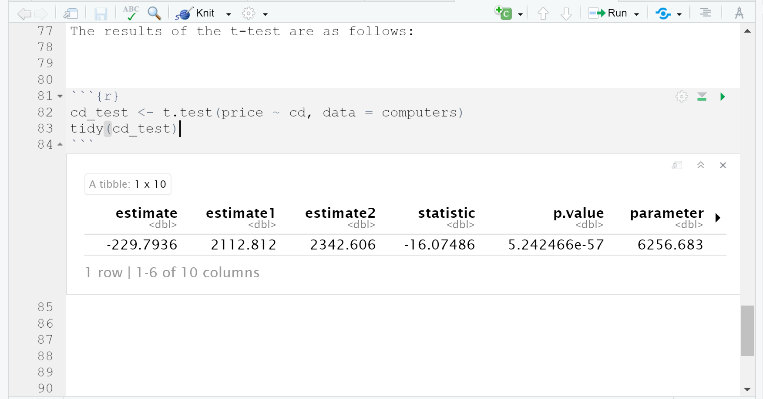
* You can use in-line blocks for dynamically-rendered text using `r objectname` like so:  
  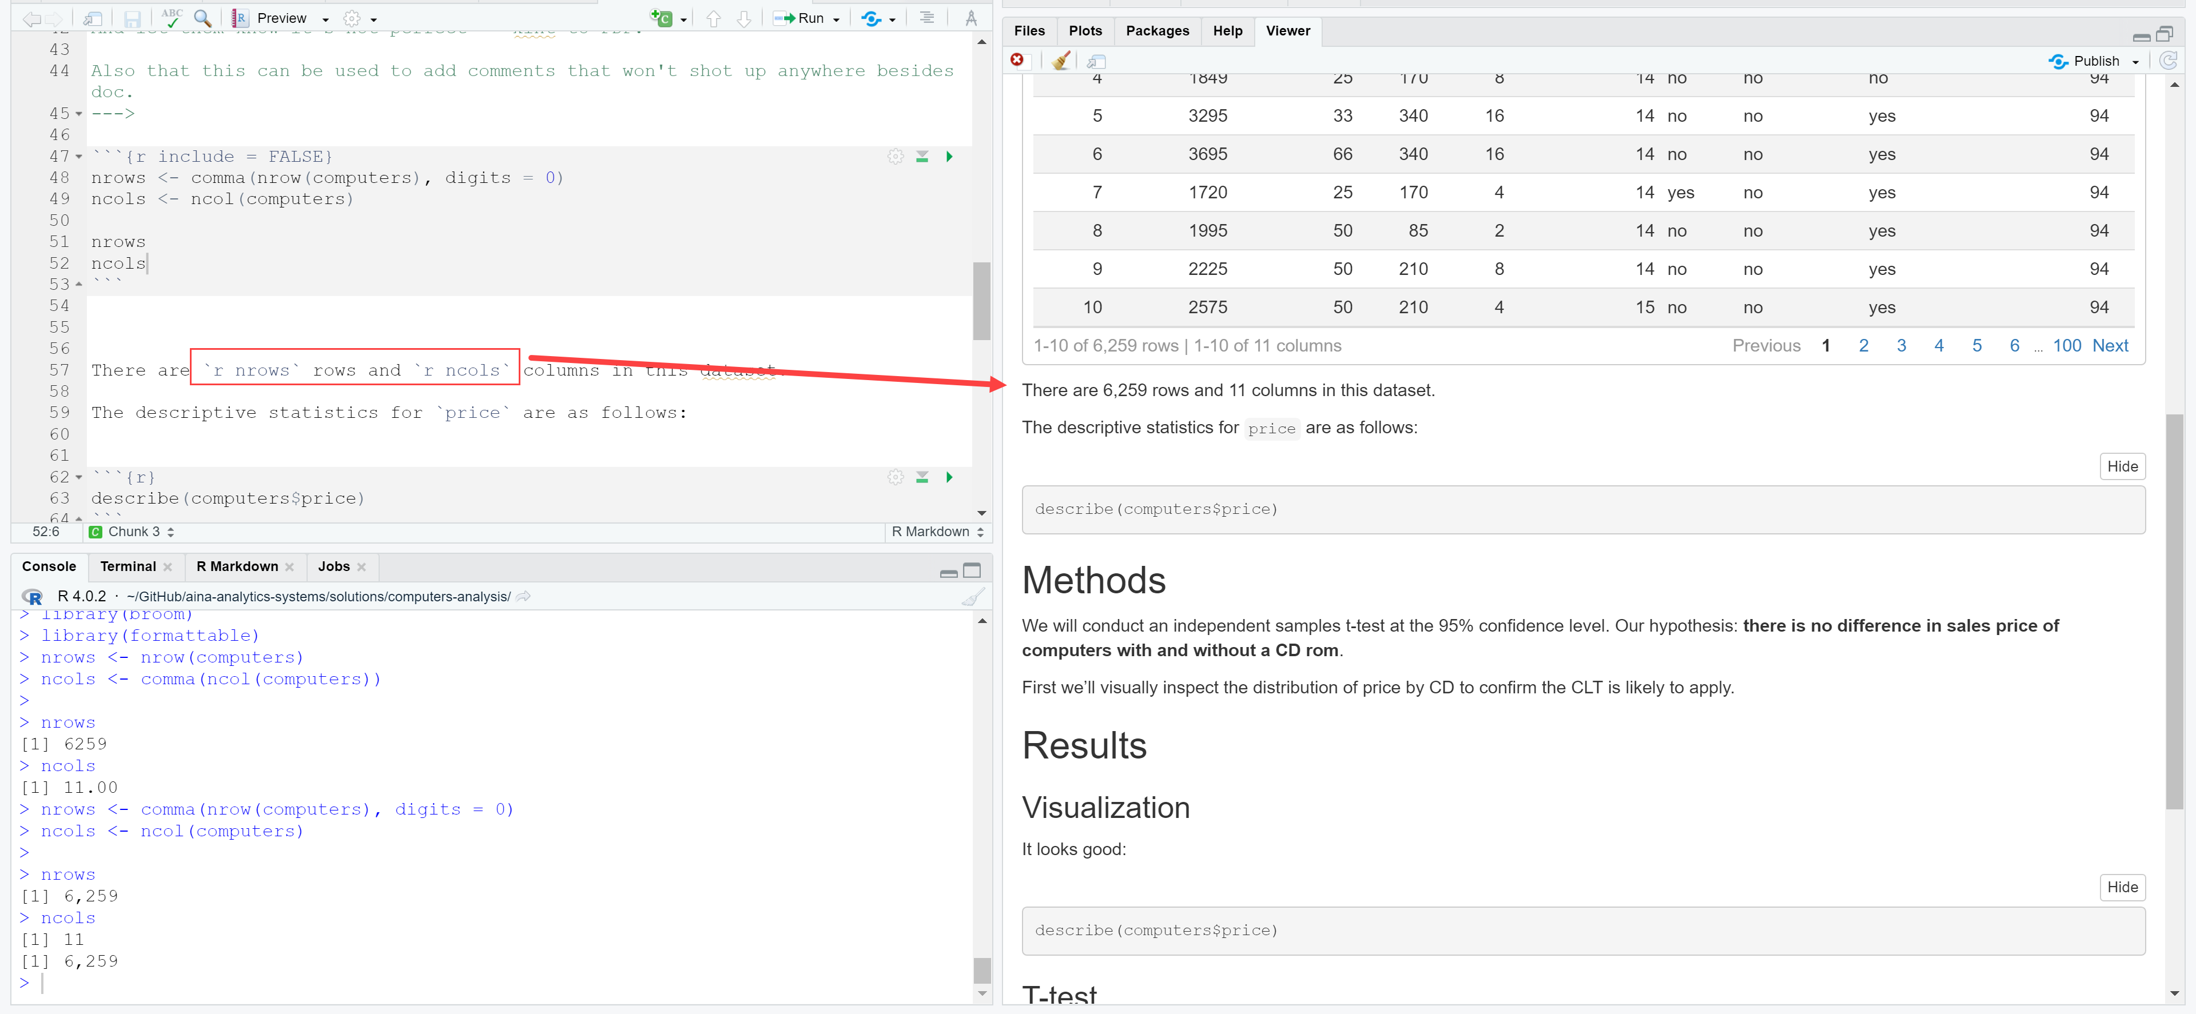
* You can add text-only comments that aren’t rendered in the doc or run by R by using the following notation (comes from HTML):

<!---

Comments go b/w the lines

--->

They’ll look like this in the notebook:

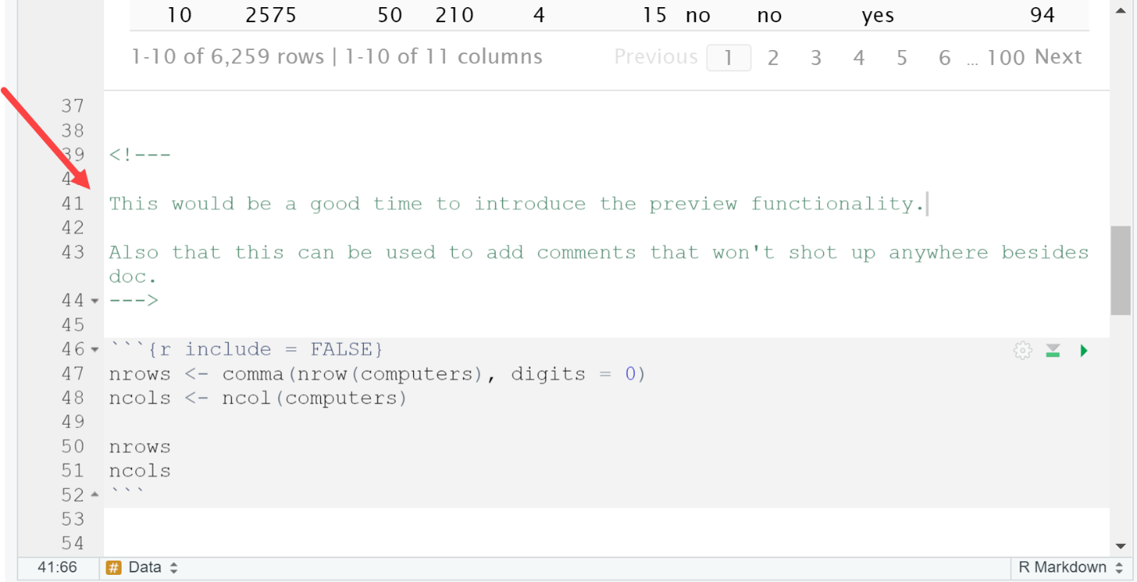

* If you’re just looking to try out some code before including it in the document, try using the console:  
  